Day 4 Preparation Topics – Backend Preparation
1. Python 3.13+
Brief Information:
Python is a high-level, easy-to-learn programming language widely used for web development, AI, automation, data science, and backend development.
Python 3.13+ includes performance improvements, better error messages, and enhanced developer productivity.
Key Features
- Easy to read and write
- Cross-platform
- Large standard library
- Huge community support
- Used with FastAPI for backend development

2. FastAPI
Brief Information:
FastAPI is a modern Python framework used to build high-performance REST APIs.
It is fast, easy to use, automatically generates API documentation, and supports asynchronous programming.
Features
- Very fast performance
- Async programming
- Easy dependency injection
Rest API architecture diagram
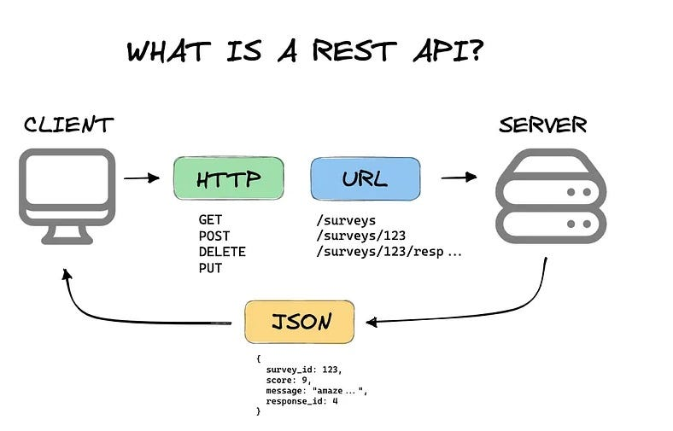

FastAPI request-response flow
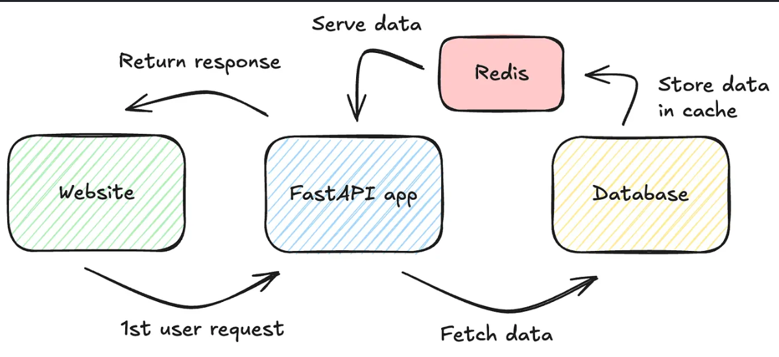

3. Pydantic V2
Brief Information:
Pydantic is a Python library used for data validation and serialization. It ensures that incoming API data follows the correct format before processing.
Uses
- Input validation
- Output formatting
- Automatic type conversion
- Error handling

Data validation flow
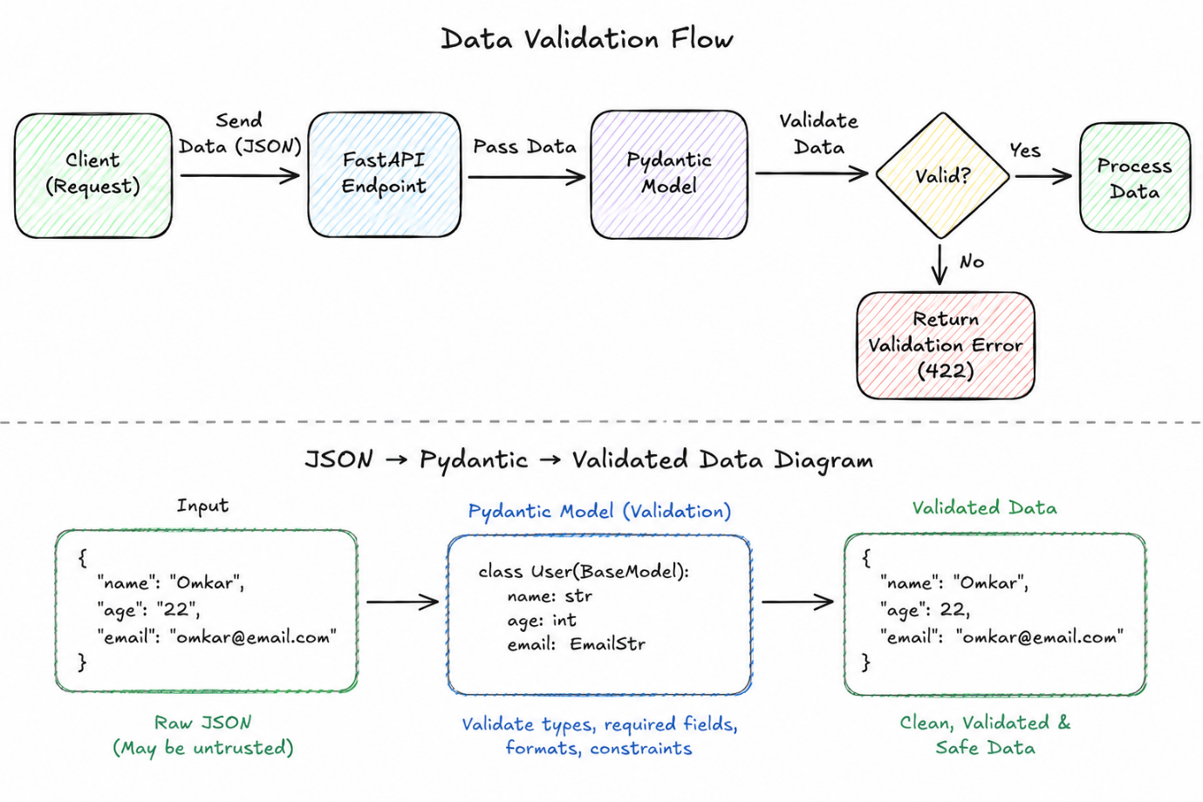

JSON → Pydantic → Validated Data diagram

4. SQLAlchemy 2
Brief Information:
SQLAlchemy is a Python ORM (Object Relational Mapper) that allows developers to work with databases using Python objects instead of writing raw SQL queries.

Advantages
- Easier database operations
- Supports multiple databases
- Reduces SQL code
- Better maintainability

Python → SQLAlchemy → Database diagram
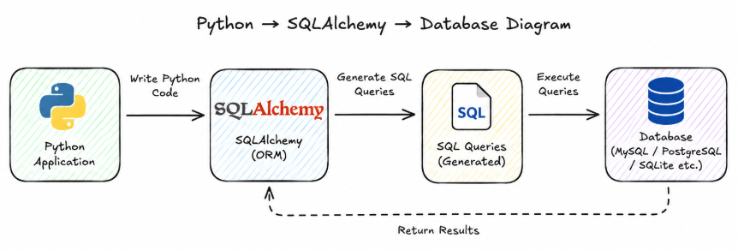

5. Alembic
Brief Information:
Alembic is a database migration tool for SQLAlchemy. It helps track database schema changes and update databases without losing existing data.
Uses
- Create migrations
- Upgrade database
- Downgrade database
- Version control for schema

6. JWT (JSON Web Token)
Brief Information:
JWT is a secure token used for user authentication. After successful login, the server generates a token which is sent with future requests to verify the user's identity.
Advantages
- Stateless authentication
- Fast verification & Secure
- Widely used
Login → JWT Token → API Access flow
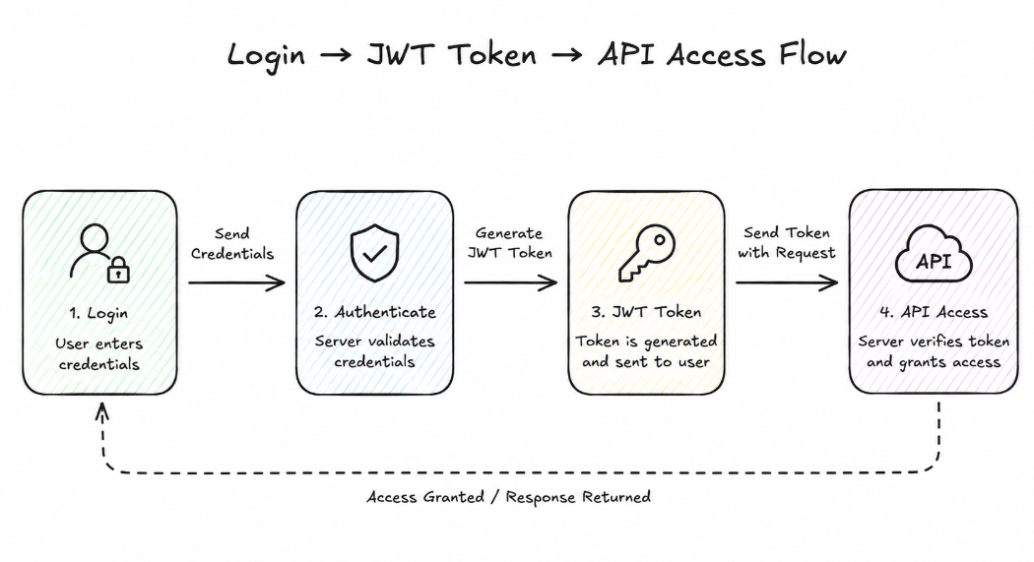
7. Refresh Token
Brief Information:
A Refresh Token is used to generate a new Access Token after the current one expires, allowing users to stay logged in without entering credentials again.
Benefits
- Better user experience
- Improved security
- Longer session management

8. RBAC (Role-Based Access Control)
Brief Information:
RBAC controls what users can access based on their assigned roles, such as Admin, Manager, or User.
Example
- Admin → Full access
- Manager → Limited management access
- User → Personal data only

Admin/User role hierarchy
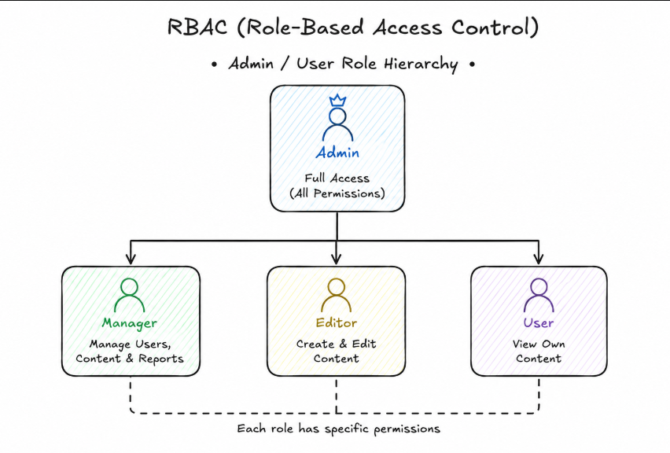

9. MFA Ready (Multi-Factor Authentication)
Brief Information:
MFA adds an extra security layer by requiring more than one verification method, such as a password and an OTP.
Examples
- Password + OTP
- Password + Authenticator App
- Password + Fingerprint
Used For
- Two-step verification diagram
- Smartphone OTP illustration

10. Celery (Background Jobs)
Brief Information:
Celery is a distributed task queue that runs time-consuming tasks in the background without blocking the main application.
Examples
- Sending emails
- Image processing
- Report generation
- Notifications

11. Redis
Brief Information:
Redis is an in-memory data store used for caching, session management, message queues, and improving application performance.
Advantages
- Extremely fast
- Stores data in memory
- Supports caching
- Used with Celery

Redis logo / Cache architecture

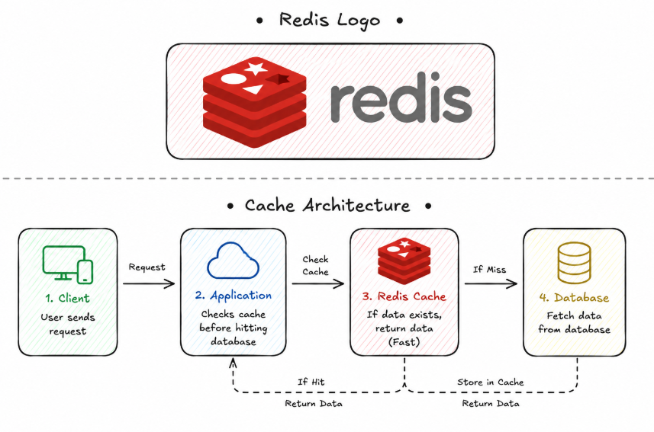

12. FastAPI WebSocket
Brief Information:
WebSocket provides real-time, two-way communication between the client and server without repeatedly sending HTTP requests.
Common Uses
- Live chat
- Notifications
- Stock market updates
- Multiplayer games

Client ↔ Server WebSocket connection
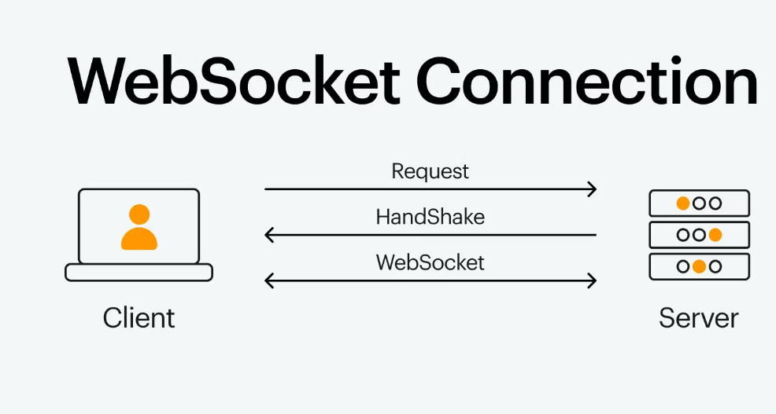

13. Redis Pub/Sub
Brief Information:
Redis Publish/Subscribe is a messaging system where publishers send messages to channels and subscribers receive them instantly.
Examples
- Chat applications
- Live notifications
- Real-time dashboards

14. FastAPI Depends (Dependency Injection)
Brief Information:
Depends() is FastAPI's dependency injection system that helps reuse code like database connections, authentication, and validation.
Benefits
- Cleaner code
- Reusability
- Easy testing
- Better maintenance

15. Redis Caching
Brief Information:
Caching stores frequently used data temporarily so future requests can be served much faster without repeatedly querying the database.
Advantages
- Faster response time
- Reduced database load
- Better application performance

16. Structlog & Python Logging
Brief Information:
Logging records important application events, errors, and debugging information. Structlog creates structured logs that are easier to read and analyze.
Uses
- Debugging
- Monitoring
- Error tracking
- Performance analysis

17. Pydantic Settings (Configuration)
Brief Information:
Pydantic Settings helps manage application configuration by loading values from environment variables and configuration files securely.
Examples
- Database URL
- API Keys
- Secret Keys
- Debug Mode
Advantages
- Secure configuration
- Easy deployment
- Environment-specific settings

